Instructions and Formatting Rules for Authors of ICSTINP
First author¹, Second author², Third author³ (Times New Roman 11pt)
¹First author affiliation, University/Institute (Times New Roman, 10pt); Email address (9pt)
²Second author affiliation, University/Institute (Times New Roman, 10pt); Email address (9pt)
³Third author affiliation, University/ Institute (Times New Roman, 10pt); Email address (9pt)
* Corresponding author: Name
Abstract
In this manuscript, basic instructions for the preparation of a paper for ICSTINP are presented. This document is an example of the desired layout and can be used as a template. The document contains information for all formats, type sizes, and typefaces in the required styles. Style rules are provided to explain how to handle equations, units, figures, tables, abbreviations, and acronyms. The English abstract is limited to 250 words in one paragraph. It should concisely state explicitly the subject or the problem, the methodology, the principal results, and their significance.
Keywords: Up to 6 Words, Separated by Comma.

Introduction
This instruction gives you guidelines for preparing ICSTINP papers. All papers must be submitted electronically in Docx format. Prepare your paper in A4 page size of 210 mm × 297 mm (8.27" × 11.69"). The length of your paper should not exceed 7 pages. Do not include page numbers.
Set the top margin to 1.5" and the bottom margin to 0.5". Left and right margins should be 0.59" and gutter 0. Header and footer 0" and 0.5", respectively. Use a single-column format and single spacing.

Prepare your paper before styling
Before you begin to format your paper, first write and save the content as a separate text file. Complete all content and organizational editing before formatting. Please note sections A-D below for more information on proofreading, spelling, and grammar.
Keep your text and graphic files separate until after the text has been formatted and styled. Do not use hard tabs, and limit the use of hard returns to only one return at the end of a paragraph. Do not add any kind of pagination anywhere in the paper. Do not number text heads-the template will do that for you.

Equations
The text size of the formula should be similar to the body text size. The formula should be placed in the middle and the serial number on the right. For example:
$$a^{2}+b^{2}=c^{2}$$ | (1)
To make your equations more compact, you may use the solidus ( / ), the exp function, or appropriate exponents. Italicize Roman symbols for quantities and variables, but not Greek symbols.

Figures and Tables
All of the Tables and Figures must be in the center of the page. The title of the Tables must be at the top of the Table and the title of the Figures must be below them at the center. Insert figures and tables after they are cited in the text.

Table 1-Table Type Styles
Subject | Font | Size | Type
Paper Title | Times New Roman | 14 | Bold
Name and Family of Authors | Times New Roman | 11 | Bold
Affiliation of Authors | Times New Roman | 10 | Normal
Section Title | Times New Roman | 12 | Bold
Section Subtitle | Times New Roman | 11 | Bold
Abstract text | Times New Roman | 11 | Normal
Keywords | Times New Roman | 11 | Normal
Body text | Times New Roman | 11 | Normal
Footnotes | Times New Roman | 9 | Normal
Title of Tables and Figures | Times New Roman | 10 | Normal
Text of Tables | Times New Roman | 10 | Normal
References | Times New Roman | 11 | Normal
- Sample of a Table footnote. (Table footnote)

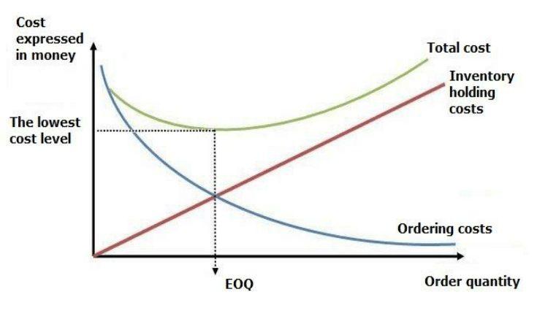
Figure 1-Figure title

Acknowledgments
Identify grants or other financial support (and the source, if appropriate) for your study. Thanks to those who helped with the preparation of the article indirectly.

Reference style
All references should be formatted according with the American Psychological Association (APA) style. In-text citations usually provide the name of the author(s) and the year the source was published. Refrain from numbering the references inside the separate text.

Attention: Persian references must be marked with [in Persian] words in the list of references.

References
Eberlein, R. L. (1984). Simplifying dynamic models by retaining selected behavior modes (Doctoral dissertation, Massachusetts Institute of Technology).‏
Homer, J. B. (2012). Partial‐model testing as a validation tool for system dynamics (1983). System Dynamics Review, 28(3), 281-294.‏
Sterman, J. (2002). System Dynamics: systems thinking and modeling for a complex world.‏ Irwin/McGraw-Hill, Boston.
Yar Mohammadzadeh, P., Mahdun, R., & GHolipur, S. (2019). Identify factors affecting the promotion of entrepreneurial culture the vocational and technical schools: the mixed method. Journal of New Approaches in Educational Administration, 10(38), 35-56.‏ [In Persian].

